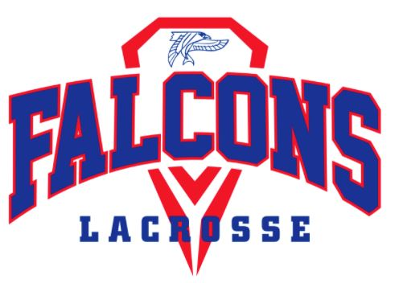 | Armstrong Boys Lacrosse  2022 Season Payment Form
PLAYER NAME: ____________________________________

ITEM | AMOUNT | ENTER $ AMT PAID | Add’l Info
Booster Club | $165 |  | Pays for coaches, buses, etc.
Player Ad | $30 |  | Optional - Complete Player Ad Order Form
Spring Warm Ups | $85 all  $25 weekly |  | Players Participating - MUST BE PAID to attend
Helmet | $145 |  | Required for new players. Booster club subsidized
Gloves | $135 |  | Optional
Pinney | $35 |  | Needed for all new players
Shooter Shirt | $30 |  | Needed for all new players
Away Game Sandwiches | $90 |  | Optional - Complete Order Form
Logo’d Water Bottle | $17.50 |  | Each NEW Player to receive (1), please mark additional
 | TOTAL | $

Make checks payable to Armstrong Boys Lacrosse Booster Club
ALL PAYMENTS ARE DUE BY FIRST DAY OF TRYOUT ON APRIL 4, 2022
CHECK #_______________ for $________________
Please scan and email to ahsboyslax@gmail.com.
Send checks to:
Ron Ledoux
5955 Wynnwood Road
Golden Valley MN 55422
Or bring form and check to the first night of tryouts.
Payment can also be made via link from Website - https://www.armstrongboyslacrosse.com/how-to-pay.html . Note online payments include an additional 2.9% plus $.30 per charge fee.

