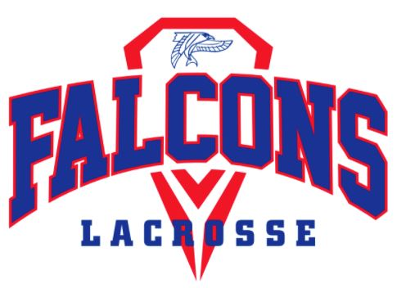 | Armstrong Boys’ Lacrosse  2021 Season Payment Form

PLAYER NAME: _____________________________________

ITEM | AMOUNT | ENTER $ AMT TO BE PAID | Add’l Info
Booster Club Player  Payment | $145 |  | Pays for coaches, busses, etc.
Player Ad | $30 |  | Optional - Complete Player Ad Order Form
Spring Warmups | $75 all  $20 weekly |  | Players Participating - MUST BE PAID to attend
Helmet | $130 |  | Required for new players. Booster club subsidized
Gloves | $135 |  | Optional
Pinney | $35 |  | Needed for all new players
Away Game Sandwiches | $50 |  | Optional - Complete Order Form
Logo’d Water Bottle | $13 |  | Each Player to receive (1), please mark additional
 | TOTAL | $

Make checks payable to Armstrong Boys Lacrosse Booster Club
ALL PAYMENTS ARE DUE BY APRIL 5, 2021
CHECK #_______________ for $________________

Please scan and email to ahsboyslax@gmail.com.
Send checks to:
Ron Ledoux
5955 Wynnwood Road
Golden Valley MN 55422
Or bring form and check to the first night of tryouts.
Payment can also be made via PayPal. Please note you’ll need to add in an additional 2.9% plus $.30.
paypal.me/Armstrongboyslax

