2021 Armstrong Boys’ Lacrosse Player Ad

Example of Player Ad
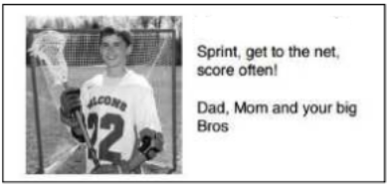
Player Name:
Message to Player:

Player Ads are $30 each.
Make checks payable to Armstrong Boys’ Lacrosse Booster Club
Mail to: -
Ron Ledoux
5955 Wynnwood Road
Golden Valley MN 55422

Email to: ahsboyslax@gmail.com
Player Ads are due by April 15, 2021.

